

**Department of CSE**

**CSE209 Lab**

**Course Name: Electrical Circuits**

**Course Code: CSE209**

**Section No: 2**

**Name of the Project:** PSpice Analysis for Maximum Power Transfer.

**Date of submission: 11/09/2021**

Student’s Name: Md Abdul Ahad Rifat

Student’s ID: 2020-1-60-215

**Submitted to**

Rashedul Amin Tuhin

Senior Lecturer

Department of Computer Science and Engineering

East West University

**Objectives:**

1. To verify Thevenin’s equivalent of the circuit theoretically, and using PSpice simulation.
2. To analyze and verify maximum power transfer theorem of the circuit theoretically and using PSpice simulation by resistance sweeping.

**Step 1:**

1. Using PSpice Simulation, determine the Thevenin’s equivalent of the circuit looking from the load resistance RL.

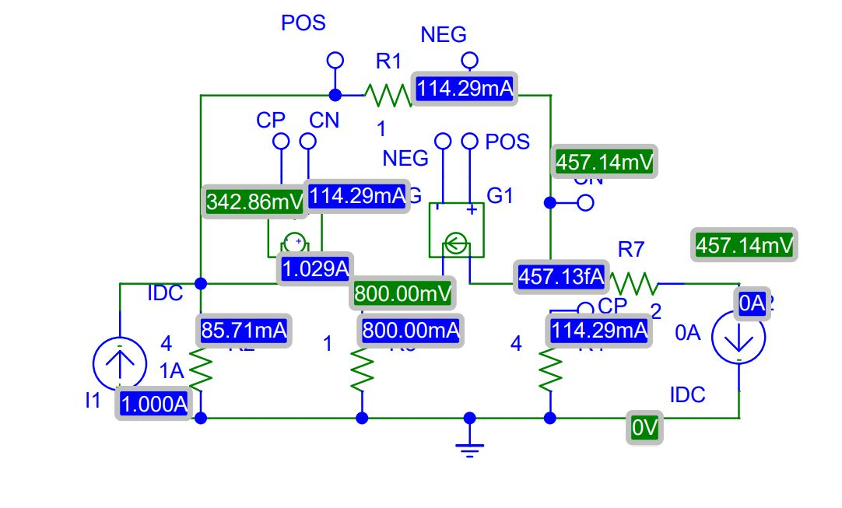**Circuit Diagram(s):**

**Figure 1.PSpice Schematic circuit diagram for VOC**

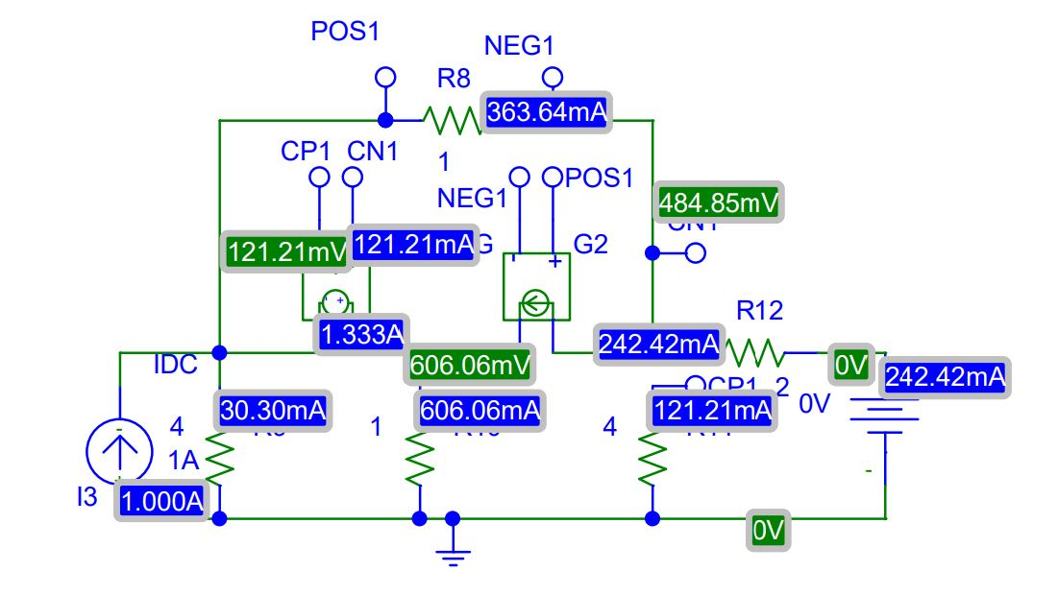

**Figure 2.PSpice Schematic circuit diagram for ISC**

In circuit 1 and circuit 2 we create to calculate RTh, where VOC **=**457.14V and ISC **=**242.42mA.

So, $R_{L}$ ${=R}_{Th}=\frac{V_{OC}}{I_{SC}}$

= $\frac{457.14}{242.42}$

$R_{Th}$ = 1.89Ω

**Step 2:**

1. From the Thevenin’s equivalent circuit, theoretically determine the value of load resistance RL for maximum power transfer. Using PSpice Simulation of the Thevenin’s equivalent circuit with RL for maximum power transfer, determine the value of maximum power transferred to RL

**Theoretical Calculation:**

**Calculation for RTh :**

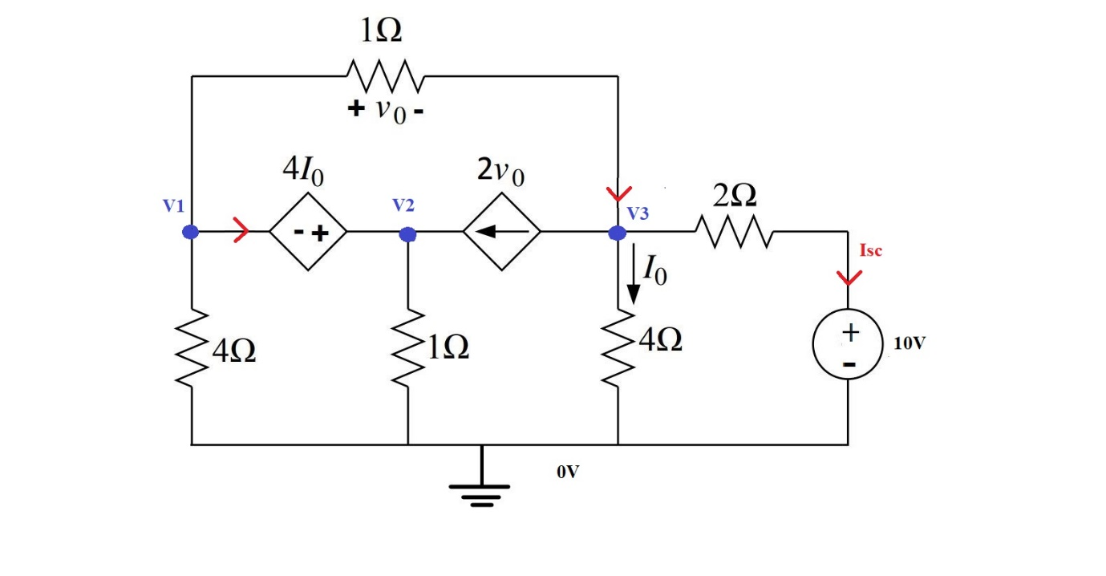

**Figure 3.Circuit for Calculating for Isc**

In circuit 3 we disconnect the load also disconnect the independent current source and this circuit has a dependent source so we connected 10V voltage source to measure short circuit current ISC.

At the Super node;

$$2V_{°}=\frac{V_{1}}{4}+\frac{V_{2}}{1}+\frac{V_{1}{-V}_{3}}{1}…………………..(1)$$

But $V_{°}=V_{1}{-V}_{3}$

Hence the equation 1 becomes;

$$-3V_{1}+4V_{2}+4V_{3}=0………………..(2)$$

At node 3;

$$2V_{°}+\frac{V_{3}}{4}=\frac{V_{1}{-V}_{3}}{1}+\frac{10-V_{3}}{2}$$

$$20=4V_{1}+0V_{2}-V_{3}………………..(3)$$

At the Super node;

$$V_{2}=V_{1}+4I_{°}$$

But $I_{°}=\frac{V_{3}}{4}$

Hence, $V_{2}=V_{1}+V_{3}………………..(4)$

Solving equation 2 to 4 we get,

$$V_{3 }=-0.607V$$

Now

$I_{SC}=\frac{10+0.607}{2}$

$$I_{SC}=5.303A$$

$$R_{Th}=\frac{V_{3}}{I_{SC}}$$

= $\frac{10}{5.303}$

$$R_{Th}=1.89Ω$$

**Calculation for VTh :**

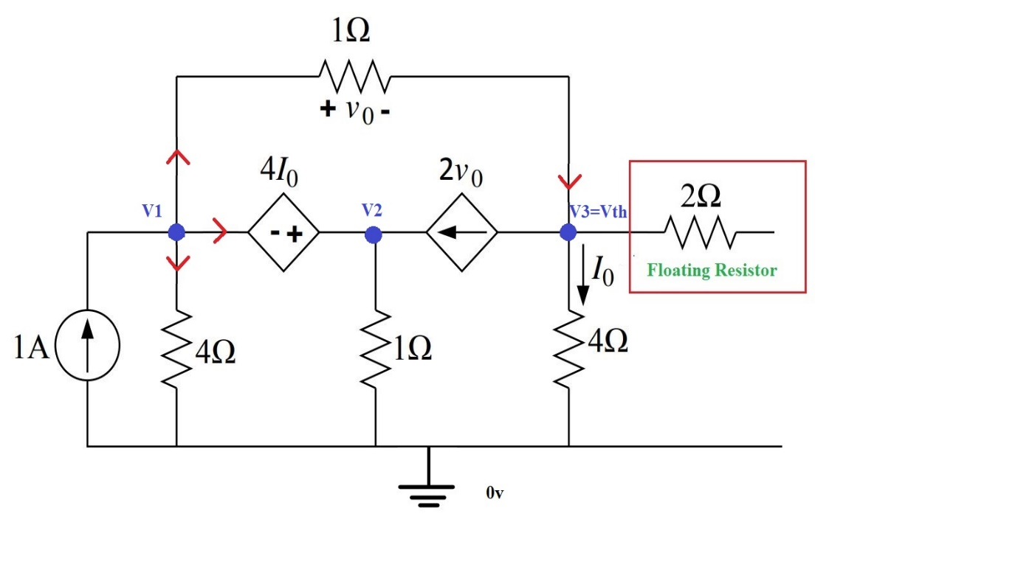

**Figure 4.Circuit for Calculating for Vth**

At the Super node;

$$1+2V_{°}=\frac{V_{1}}{4}+\frac{V_{2}}{1}+\frac{V_{1}{-V}_{3}}{1}…………………..(1)$$

But $V_{°}=V_{1}{-V}_{3}$

Hence the equation 1 becomes;

$$-3V_{1}+4V_{2}+4V_{3}=4………………..(2)$$

At node 3;

$$2V_{°}+\frac{V_{3}}{4}=\frac{V_{1}{-V}_{3}}{1}………………..(3)$$

At the Super node;

$$V_{2}=V_{1}+4I_{°}$$

But $I_{°}=\frac{V_{3}}{4}$

Hence, $V_{2}=V_{1}+V_{3}………………..(4)$

Solving equation 2 to 4 we get,

$$V_{Th}=V_{3 }=0.458V$$

**Calculation for Maximum Power Transfer:**

We all know,

DC Circuit Pmax =

=

Pmax = 27.74mWatt

**Step 3:**

1. Using PSpice Simulation with resistance sweep, determine the value of RL for maximum power transfer and the corresponding maximum power.

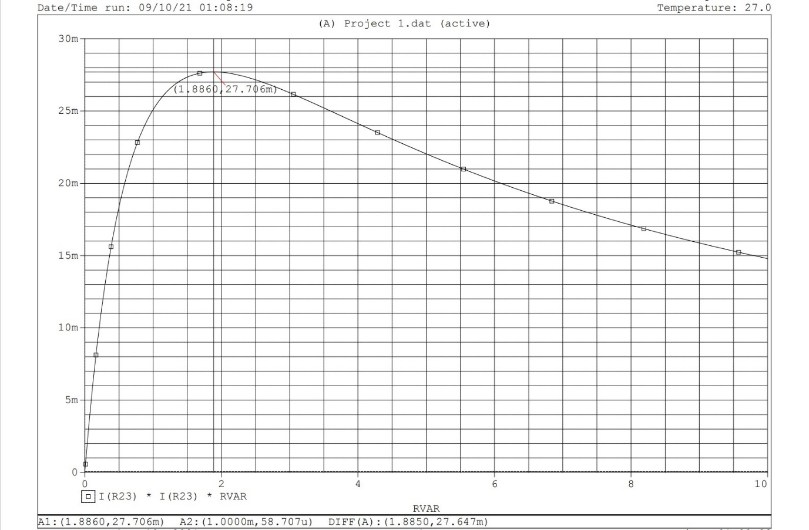

**Figure 5.PSpice Simulation Graph for Maximum Power Transfer**

**Step 4:**

1. Compare the value of RL and maximum power obtained in steps 2 and 3

**Table 1.Comparing Theoretical Value and PSpice Simulation Software Value**

|  |  |  |
| --- | --- | --- |
| Name | Theoretical Value | PSpice Simulation Value |
| RL | 1.89Ω | 1.887Ω |
| Pmax | 27.74mWatt | 27.706mWatt |

So we can say that Theoretical Value and PSpice Simulation Software Value are quietly same.

**Conclusion:**

Meanwhile using Lab experiments 4, 6, 7 we have done our Lab project. Now we know how to work Thevenin's equivalent circuit and this circuit made our life easy. If we know Voltage and Resistance in a complex circuit then we make a simple series of Thevenin's equivalent circuit and we also calculate maximum power transfer using this circuit. Within a real-life Thevenin's equivalent circuit helps us to make an easy and cheap cost circuit also its saves our time.